Assignment 1

Perform the following operations

1. Setting Router Modes on 2600 Series Routers

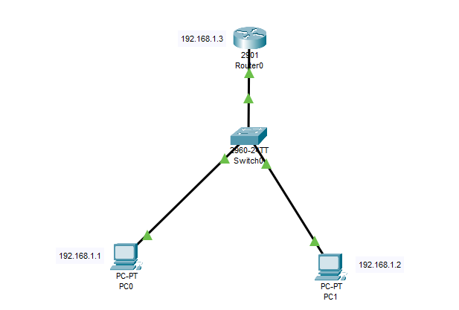

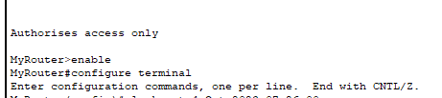

1. Changing Hostname of the Router

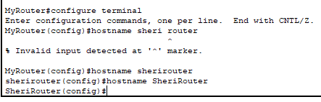

1. Configuring Date and Time on the Router (Clock Set Command)

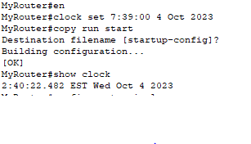

1. Setting a banner on the Router

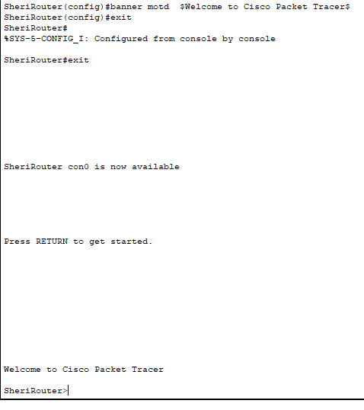

1. Displaying the Router’s Running-Configuration and Start-Up Configuration

SheriRouter>enable

SheriRouter#show running-config

Building configuration...

Current configuration : 718 bytes

!

version 15.1

no service timestamps log datetime msec

no service timestamps debug datetime msec

no service password-encryption

!

hostname SheriRouter

!

!

!

!

!

clock timezone EST -5

!

!

!

!

ip cef

no ipv6 cef

!

!

!

!

license udi pid CISCO2901/K9 sn FTX152452M5-

!

!

!

!

!

!

!

!

!

!

!

spanning-tree mode pvst

!

!

!

!

!

!

interface GigabitEthernet0/0

ip address 192.168.1.3 255.255.255.0

duplex auto

speed auto

!

interface GigabitEthernet0/1

no ip address

duplex auto

speed auto

shutdown

!

interface Vlan1

no ip address

shutdown

!

ip classless

!

ip flow-export version 9

!

!

!

banner motd ^CWelcome to Cisco Packet Tracer^C

!

!

!

!

line con 0

!

line aux 0

!

line vty 0 4

login

!

!

ntp server 192.168.1.3

!

end

SheriRouter#

SheriRouter#show startup-config

Using 707 bytes

!

version 15.1

no service timestamps log datetime msec

no service timestamps debug datetime msec

no service password-encryption

!

hostname MyRouter

!

!

!

!

!

clock timezone EST -5

!

!

!

!

ip cef

no ipv6 cef

!

!

!

!

license udi pid CISCO2901/K9 sn FTX152452M5-

!

!

!

!

!

!

!

!

!

!

!

spanning-tree mode pvst

!

!

!

!

!

!

interface GigabitEthernet0/0

ip address 192.168.1.3 255.255.255.0

duplex auto

speed auto

!

interface GigabitEthernet0/1

no ip address

duplex auto

speed auto

shutdown

!

interface Vlan1

no ip address

shutdown

!

ip classless

!

ip flow-export version 9

!

!

!

banner motd ^CAuthorises access only^C

!

!

!

!

line con 0

!

line aux 0

!

line vty 0 4

login

!

!

ntp server 192.168.1.3

!

end

SheriRouter#

6:Enable Password and Enable Secret Password with the Encryption Techniques/Levels

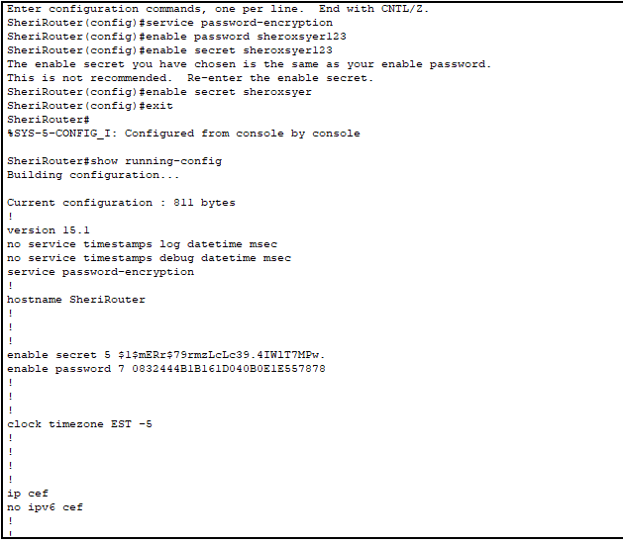

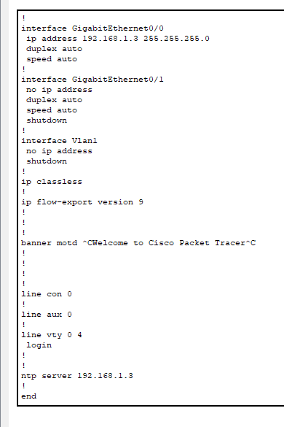

7:Usage of Router with different topology.

Star topology:

